SCENARIO-1

SET SERVEROUTPUT ON;

BEGIN

FOR cust IN (

SELECT CustomerID,

InterestRate,

Age

FROM Customers

) LOOP

IF cust.Age > 60 THEN

UPDATE Customers

SET InterestRate = cust.InterestRate - 1

WHERE CustomerID = cust.CustomerID;

END IF;

END LOOP;

COMMIT;

END;

/

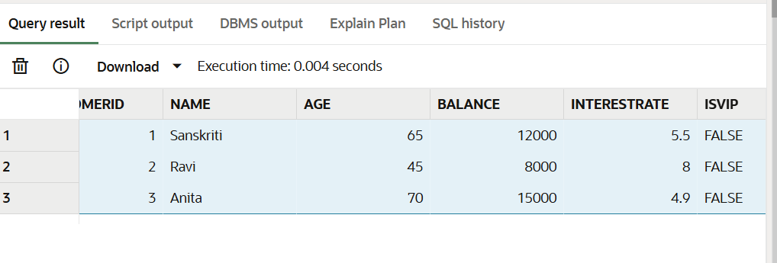

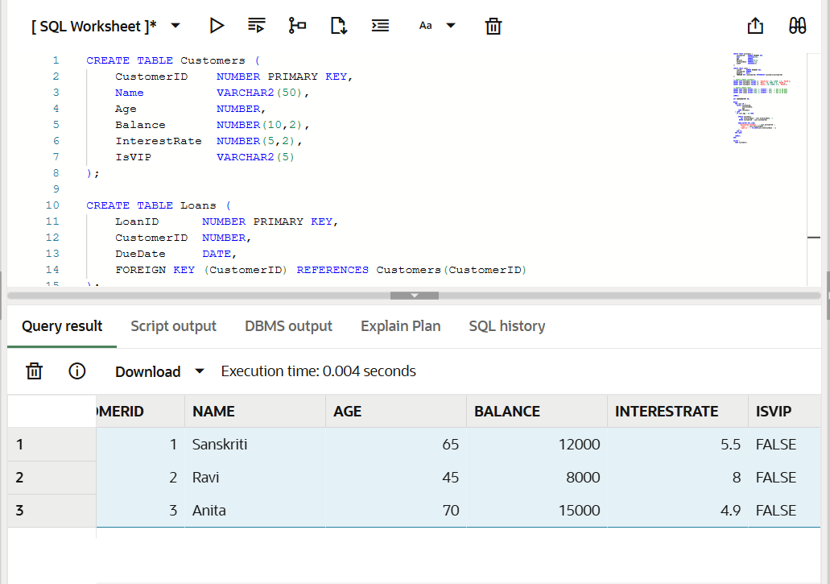

SCENARIO-2

SET SERVEROUTPUT ON;

BEGIN

FOR cust IN (

SELECT CustomerID, Balance

FROM Customers

) LOOP

IF cust.Balance > 10000 THEN

UPDATE Customers

SET IsVIP = 'TRUE'

WHERE CustomerID = cust.CustomerID;

END LOOP;

COMMIT;

END;

/

SELECT CustomerID, Name, Balance, IsVIP

FROM Customers;

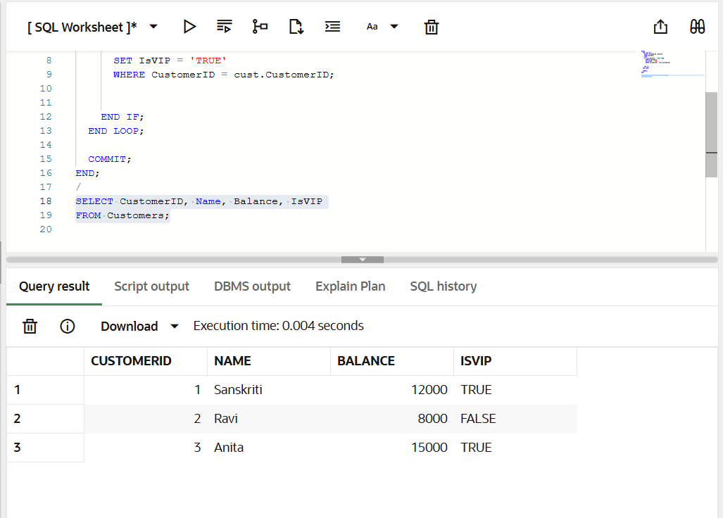

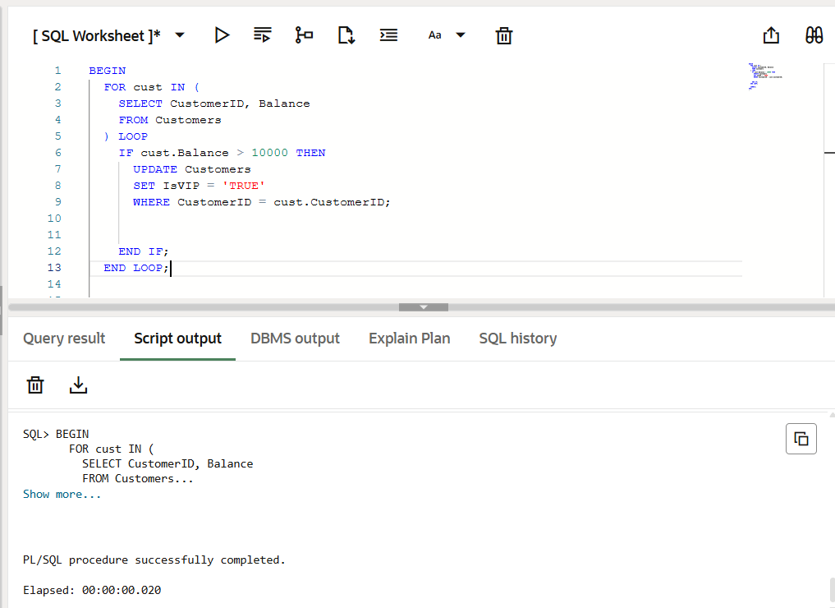

SCENARIO-3

SET SERVEROUTPUT ON;

BEGIN

FOR loan_rec IN (

SELECT LoanID, CustomerID, DueDate

FROM Loans

WHERE DueDate <= SYSDATE + 30

) LOOP

DBMS_OUTPUT.PUT_LINE(

'Reminder: Loan ID ' || loan_rec.LoanID ||

' for Customer ID ' || loan_rec.CustomerID ||

' is due on ' || TO_CHAR(loan_rec.DueDate, 'DD-MON-YYYY')

);

END LOOP;

END;

/

SELECT LoanID, CustomerID, DueDate

FROM Loans

WHERE DueDate <= SYSDATE + 30;

